

**MODULE:**

**Computing Project**

**TITLE:**

**Hungry Bites**

**December 2018**

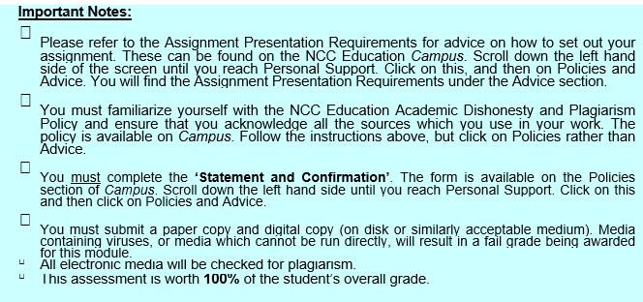

|  |  |  |
| --- | --- | --- |
| Student Name: Muhammad Sazib Hossain | Student Number: 00165749 | Centre:  Daffodil International Academy |

**Marker's comments:**

**Moderator's comments:**

|  |  |  |
| --- | --- | --- |
| **Mark:** | **Moderated** | **Final** |
|  | **Mark:** | **Mark:** |

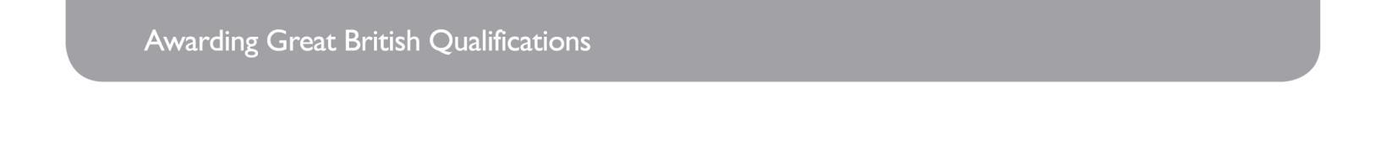



|  |
| --- |
| ***Each time you submit an assignment you must attach this statement as the cover page for both the hard copy and the electronic version. If the statement is missing your work will not be marked.*** |

Student declaration:

I have read and understood NCC Education’s Policy on Academic Dishonesty and Plagiarism.

I can confirm the following details:

Student ID/Registration number: 00165749

Name: Muhammad Sazib Hossain

Centre Name: Daffodil International Academy

Module Name: Computing Project

Module Leader: Mr. Rafiul Huq

Number of words: 6051

I confirm that this is my own work and that I have not plagiarized any part of it. I have also noted the assessment criteria and pass mark for assignments.

|  |
| --- |
| Due Date: 26/10/2018 |
| Student Signature: sazib |
| Submitted Date:2610/2018 |



**Project name: Hungry Bites Management System**

**Author: Muhammad Sazib Hossain (00165749)**

**Center: Daffodil International Academy**

# Abstract:

To get food from anytime and anywhere is very essential in modern day. It helps to enjoy the best desire and save time from busy life. Hungry bites management system is basically going to be an online based restaurant management system. People who want to enjoy delicious food but do not go outside to collect. This application will be very helpful for them. After creating an account the users will be able to select and order their desire food around the city.

As it is going to be a web based system. It will contribute to give customers their own choice to enjoy their desire food without moving from their existing places. The full system’s data are stored into a database it helps to ensure a paperless environment.

Table of Contents

Abstract: 4

Acknowledgement: 7

Introduction 8

Project background study 8

The system developed: 9

Solution that have emerged: 10

The main aims and objectives of the project: 10

Overview: 11

Analysis 14

Introduction: 14

Functional requirements: 14

Non-functional requirements: 15

Prioritization of the requirements 15

Use case Diagram 17

System architecture: 18

Conclusion: 18

Design 19

Introduction 19

Structural model: 19

Behavior model 20

Justification for the method: 22

Implementation: 23

Introduction: 24

Choice of programming language: 24

System cutover from the development architecture to the implementation architecture: 25

Data migration from the existing architecture to development architecture: 25

Training: 27

Conclusion: 27

Other project issues: 27

Introduction: 27

Project management: 27

Risk Management: 28

Configuration management: 29

Testing: 30

Unit Testing: 30

Integration testing 35

Summary: 39

Conclusion: 39

Evaluation of work 39

Strength of the system 41

Weakness of the project 41

Further development: 42

Bibliography 43

Appendix: 44

Requirements specification: 44

Use case Description: 45

Testing: 49

User Guide 60

System code: 65

# Acknowledgement:

By the grace of almighty I have completed the documentation of my proposed system. To do this work I tried my level best to fulfill the requirements that I have specified in my project proposal.

A special thanks to my module leader Mr. Rafiul Huq who helps me every steps of this course. Without his help and guideline, it could not be possible to complete this project in-time.

# Introduction

In order to produce a new system it is very necessary to deep analysis on current system. For this, I have taken some initiatives to check how restaurant manage their existing system, how can manage their customer data, how they manage their staff’s data and how they provide their best possible services. I have defined some problems of their current system and try to solve these as well as add some feature to make their system better. I also mentioned my aims and objectives of the proposed system in my project proposal.

## Project background study

Online food management is very helpful in modern days. It is going to be turned out one of the most important and biggest industries in the modern world. Already it has been taking a large economic aspect in modern world as like as United Kingdom and many countries of Europe.

There are many countries especially in south Asia is not tainted to take online services. The reason lies behind is, most of the country in this areas are not enough developed. Beside this, the people in these countries are not lead costly lifestyle. Furthermore, the structural position of the countries also hinders to take this kind of service. But now-a-days people want to be digitalized and toward to get online and standard services.

There are many programs available now related to the project as like as Food Panda (Food Panda, 2018), Pathao Food (Pathao, 2018), Hungry naki (Hungry Naki, 2018). But they provided service as third party organization. The Hungry Bites is going to provide online services as their own organization. As a result the restaurant will be promoted as well as the customer will get a reliable source.

## The system developed:

The hungry bites management system will be a web application. The system will be very helpful for the food lover because they can order food through online with their choices. Beside this it will be also very helpful for the owner of the restaurant as he can store his staff information, notify the all users about new food or offer on existing food as well as the owner can get an opinion about their services, food quality etc. through forum.

To use this system, the customer must create his own profile through registration. After completing registration the users are ready to system. Then the user will log in the system and choice dishes from menu and food category and also can order their desire dishes. Beside this, they can update their profile information as well as can provide opinion or review about the restaurant o forum section. Furthermore, the user can comment on other post.

When the system user logged as an admin he can upload product. Accept or reject the order, beside this the admin will be able to notify the entire customer at a time. The admin also can take attendance of the staffs.

## Solution that have emerged:

The proposed system will be web based system where people can access from anywhere but the service will be provided within Dhaka city. The customer from Dhaka will be access and get their services. In this system, the user’s information, food information, order information will be stored dynamically. This will facilitate the owner and the customer’s accordingly. There is no chance to loose data due to the advance database system as well as using cloud server. Now the system will be built according to the more requirements which will benefit both sides.

## The main aims and objectives of the project:

**Project Aims:**

1. To help the customer to find out favorites dishes.

2 To order Food from anywhere.

3. By using this system customers can expose their opinion in a community.

4. To take attendance of the staff the owner can use it.

5. By using this system the customers will notify about new offer as well as launching new dishes.

6. The admin of the system can accept or reject the order.

**Project Objectives:**

1. The user must complete their registration to use the system. Without registration the user will not be able to get advance feature of the system.
2. The owner will log in as admin to confirm the order.
3. Optimizing paper work.
4. Making process as fast as possible.
5. Increasing interaction with users.
6. User can browse from mobile phone.

## Overview:

**Initial study:** I visited some restaurant and observed their current how they manage their organization. I gave more focused on the customers how they want to get services from the restaurant. I visited and talked with a good number of owners who start a small startup. I also talked with some foreigners visiting our country to come up with the upgrade online based system.

**Feasibility study:** To implement hungry bites management system there are many questions arriving such as cost, efficiency and security of the system. The main focus in this section will be about cost benefit where the owner of the system will be helpful to provide the better service as well as limited expenses (Mukund, 2018).

**Analysis:** functional and non-functional requirements including with their prioritization such as must have, should have, and could have will be completely represented in this section. Beside this, the system architecture will be presented graphically by using use case diagram.

**Design:** In this phase I mapped out the behavior model and structural model of the system. It will help to understand easily how the system is going to look like and the behaviors of the system

**Implementation:** this is the most important part of a project. In this section I defined the languages that I am going to use to develop the hungry bites management system. I also deploy the database table, entity and attributes and I also describe the role of the users of the system.

**Feasibility study:** Feasibility study is used to analyze to make sure that the project is viable for both sides in business and technique. The result of the feasibility study helps to take a decision for analyst that the project whether to continue or not

**Economic feasibility:** Economic feasibility is basically cost and benefits feasibility of the proposed system. The hungry bites management system can be determined economic feasible because:

* The required budget for the development for the hungry bites management system is competitively lover then the benefits will provided the proposed system.
* The cost for the using of the system is not so high rather than the cost of user getting their food by own.
* The system is very user friendly that the end users need not to provide training. So the training cost will be saving.

Estimation for deploying the system is given below:

|  |  |  |
| --- | --- | --- |
| **Equipment** | **Reason** | **Cost** |
| **Computer** | For the operating and maintaining the whole system | 34,500*2 = 69,000taka |
| **Server** | For storing records and details of the system | 35000 taka |
| **GPS Tracker** | For security of the customers. | 25,000 taka |
| **Web Hosting** | For operating the site online | 5,000 taka |
| **Firewall** | For security of the data. | 5,800 taka |
| **WIFI** | For browsing the system | 3000 taka |
| **Total Cost** | | 1,42,800 taka |

(BD Stall, 2018), (Star Teach, 2018).

**Operational feasibility:** Operational feasibility provides how the proposed system will solve the current system problems and meet with the business requirements (UMSL, 2018).

The proposed system is operational feasible because the system will meet with the user’s needs and the system will be able to access multiple users at a time.

**Technical feasibility:** Technical feasibility checks that if the new technology is required for deployed the proposed system, the organization and users are able to maintain these or not. It also thinks about the technical knowledge of the user for using the system (Investopedia, 2018).

the proposed system is technical feasible because now-a-days using smart phone, tablets even in PC is common and there need not training to operate these and the proposed system will run through these devices.

# Analysis

Introduction: In this part of the document basically the functional and non-functional requirements will be identified. A use case diagram will be also included that represent the requirements. Beside this high level system architecture will be also included in this section.

## Functional requirements:

Functional requirements are defined as the system must need to perform. Without these requirements the system will not gain the target success. The following requirements are the functional requirements for the hungry bites management system:

* Registration
* Log in
* users can
  + order food
  + search food by category
  + edit their profile information
  + post on the blog page
  + comment against the post
  + delete the comment
* Admin can
  + Accept or reject the order
  + upload new item
  + take all the staff attendance
  + Add new staff
  + notify registered customer
  + post on the blog page
  + comment against the post
  + delete the comment

## Non-functional requirements:

Non-functional requirements are the feature that defines how well the functional requirements will be worked. Non-functional features for the hungry bites managements are:

* time
* Efficiency
* Portability
* Validation check
* Security
* Testability
* System accessibility
* Maintainability
* Quality of the system

## Prioritization of the requirements

There are many techniques to prioritization the requirements of the project. All of the techniques have chosen MoSCoW prioritization techniques.

|  |  |
| --- | --- |
| Must have requirements are minimum requirements for the system. without these requirements the system will not meet the aims and objective of the project | * User registration * Log in process * Food order process * post on the forum * take staff attendance * upload product * notify all users |
| Should have requirements are less important then Must have requirements. The system will be useful without these features but the system will be more effective by adding should have requirements. | * comment on the post * remove food from cart * add new staff * calculate total price * edit user profile information |
| Could have requirements are those requirements that makes the system desirable but not vital. | * Create a voucher * confirming after order |
| Won’t Have this time requirements are those requirements that will not developed until further development. | * Create account settings * Card payment method * log in control |

(Project Smart, 2018).

## Use case Diagram

Use case diagram represents the user interaction with the system. The use case diagram of the hungry bites management system is given below:

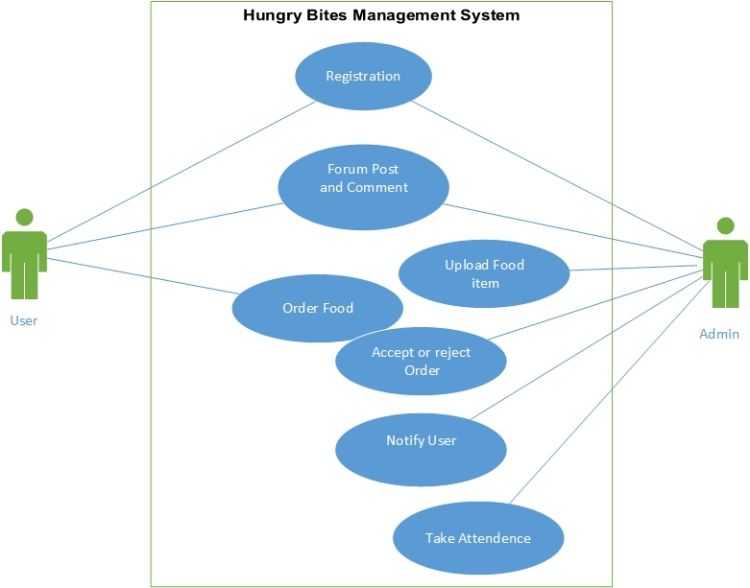

Figure: Use Case Diagram of the system.

## System architecture:

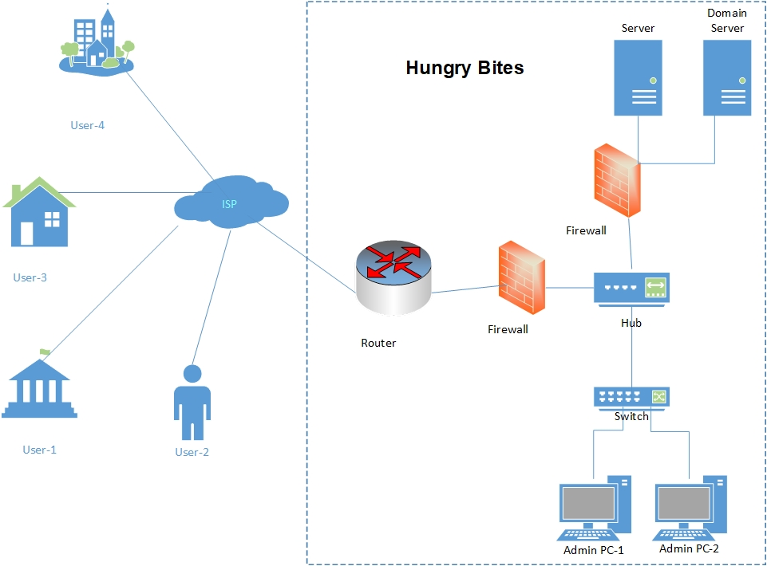

Figure: System architecture of the Hungry Bites

Conclusion: This section captured the requirements of Hungry Bites management system with functional and non-functional requirements. Beside this it also covered Use case diagram of the system as well as system architecture.

# Design

Introduction: this section is going to covered with the structural model and behavior model. This two diagrams is based on the requirement specification and system activity

## Structural model:

**ERD Diagram**

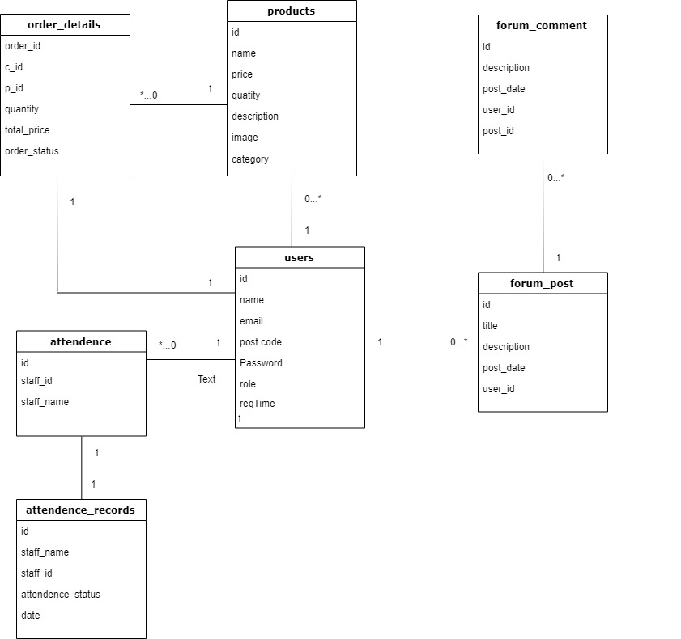

**Figure: ERD diagram of the system.**

## Behavior model

**Activity Diagram:**

An activity diagram will represent the system interact with the users through following users activity. The activity diagram of the system is given below:

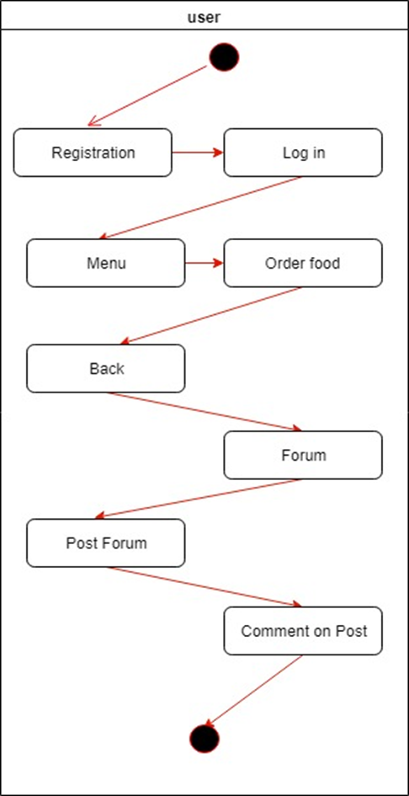

**Figure: Users activity with the system**

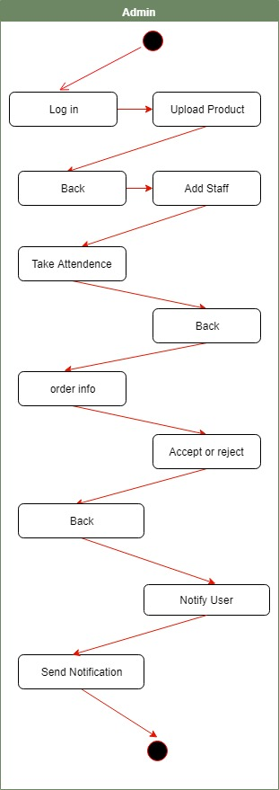

**Figure: admin activity with the system**

## Justification for the method:

There are lots of methodologies to build up a project successfully. Different methodologies maintain their own structure containing with specific requirements and procedure. Nevertheless, the activities of the project can be done by following some methodologies. To build up hungry bites management system I have followed these methodologies:

• SSADM

• Prototyping

• DSDM

**SSADM:** SSADM is basically project management methodology which is known as Structured Systems Analysis & Design Method. It’s based on waterfall model and very well-known and efficient methodology to analysis and design of an information system. By using this methodology it create a great chance to analysis and design better for hungry bites. Beside this, Logical Data Modeling, Data Flow Modeling and Entity Behavior Modeling are key techniques that are used to make a project better and viable (Techopedia, 2018) .

**Prototyping:** Prototyping is one of the most popular and effective technique where a demo solution can be deployed before any sorts of high level design and development takes in action. It helps a developer to understand the key requirements of the system and how the actual project will be look like. This also helps a developer to develop the initial stage of requirements and collect feedback about the system from the end user (Sauter, 2018).

**DSDM:** DSDM is formally known as Dynamic System Development Method.it is an agile methodology that is focused on the full project lifecycle. It is very popular for making quality compromising project. It’s basically focused on eight business principles and makes collaboration with the users which helps a developer to make better and efficient application. For hungry bites management system DSDM methodology is chosen.

DSDM is basically works based on time box. It divided the entire project life time into time box. Before that it is very necessary to priories the requirements by using Moscow

Prioritization criteria. In case Time boxes are adequately passing on the Must Have and the Should Have (the ordinary case) at the agreed time. Timebox is help to boost up confident at the project increment level (Agilebusiness, 2018).

# Implementation:

Introduction: the section will cover what kinds of programming language I used to build up the Hungry bites management system. Beside tis, this section is going to cover the development and implementation architecture as well as training for the system using.

## Choice of programming language:

There is so much programming language to develop a web based application. Among all of them I have chosen following language to develop the system:

* HTML
* CSS
* BOOTSTRAP
* JAVASCRIPT
* JQUERY
* PHP
* MYSQL

I have completed design for the system by using HTML, CSS and BOOTSTRAP. I have given structure of navigation bar and different form by using HTML and make them more beautiful and realistic by using CSS. Sometimes I have used JAVASCRIPT to give effect such as slider and validate form by using JQUERY click event. BOOTSTRAP helps me mostly to design the system. I made the system dynamic by using PHP and MYSQL. PHP is mostly used back end to build up the system. It is used to create session, validate form and so more. To work on Create Update, Retrieve, Delete I have used MYSQL function. I also used PHP Mailer function o notify the user.

Reason for choosing these languages:

* Now-a-days most of the web based programs are made by PHP language.
* Very flexible with code architecture.
* Easy to maintain and develop.
* Easy to implement.
* Need to internet connection or real server to test the program.

## System cutover from the development architecture to the implementation architecture:

Pilot: this is one way to implement a new system in an organization. in this way one of the part of the developed system is going to implement for checking that the part of the system is running smoothly or not.

Parallel: in this way the developed system runs along with the old system.

Big Bang: in this case, the developed system deployed directly. Old system is not allowed after deployed the new system.

For Hungry Bites management system I am going to choose parallel strategy. As it runs existing system with new system, there is a big chance to recover if the new system is not working properly. My proposed system is going to be changed the whole system. During implement it provides surety that I have a backup plan if the system got failure for any reason. That’s why I have chosen Parallel strategy.

## Data migration from the existing architecture to development architecture:

In existing system the organization inserted their data manually. Most of the data was kept in papers which has a plenty of chance to data lost. It is very necessary to migrate data from old system to new system when an organization moves into a new system. An IT expert will perform this task. He will insert user information, Product information, attendance and attendance record into new system through MYSQL service. Beside this new information such as forum post and comment will also keep in the same way. After that the database will be stored in a server. It is also require that a specialist will back up the data in regular basic. Once the data is stored into the database it is very easy to update delete whenever is necessary.

|  |  |
| --- | --- |
| **Table name** | **Works** |
| Users | This table will contain with the information of system users. |
| Products | This is for product information such as product name, product price, and description. |
| Order details | This table contain with the order details information. How many order are pending in the system and huh many order acre accepted is going to show. |
| Attendance | Basically this table contain with the staff information such as staff name and their id. |
| Attendance record | In this table the record of the staff attendance is kept stored. The staff who is preset and who are absent is going to see from tis table. |
| Forum Post | This table contains the all post of the forum. |
| Forum comments | In this table all the comments are kept stored. |

## Training:

Training is one of the most important factors when an organization moves with new system. It increases the efficiency of the system as well as the proper utilization of the system. By training the staff can understand how to operate the new system quickly and effectively. Beside this, they will be able to understand the error message and fix up the error message with providing right input. Furthermore, if any problem occurs during the training session, the trainer will fix up the problem quickly and will be aware for the problem and take necessary steps that the problem is not occur in future. a week can be kept for the training session (Shetty, 2018).

Conclusion: This section covered to describe the programming language that I have chosen for developing the system along with the system cutover from development architecture. This section also describes the data migration from the existing system to developed system as well as necessary training to maintain and use the system.

# Other project issues:

Introduction: this section is going to cover the approach that I have taken for project management, the risk can arise of the project and how could I handle them. Beside this it is also describe the configure management and testing of the project.

Project management: project success depends on the project management. Project is a particular arrangement of activity intended to achieve a solitary goal. All ventures must be taken care of expertly to convey it on time. In the event that it neglects to meet the prerequisites inside the due date at that point it's a failure.

There are five phases to maintain a project:

1. **Initiating:** in this stage, the idea that is taken for the proposed system or project is being checked whereas the idea provide benefits or not for the organization.
2. **Planning:** the total plan will discuss in this phase. It outlines the project duration, priorities, budgets as well as the project resources.
3. **Execution:** in this part the execution of the project will be started. The project task is distributed and team member are assigned their responsibilities in this project.
4. **Monitoring and controlling:** the project manager will evaluate the project progress and will take action if necessary.
5. **Closing:** it’s the last stage of the project managements. In this stage the full project is reviewed and takes decision if the project is success or not (Bisk Education, 2018).

Risk Management:

Risk management means the identification, evaluation and prioritization of the project risk that can be happened and for that the tolerance level of demerge. The risks can be occurred for many factors such as financial dubiousness, legal problems, strategic management errors, natural calamities. Securing data related risks and data administration data has turned into the best need for the organizations that are digitized. So, risk should be identified to provide security of the organization as well as the customers.

Security is the most important part of the Hungry Bites Management System. the order information is the most important data of this system and it is prone to threat or attacks by authorized access or hacked. The system is not strong enough to deal with all sorts of threats and attacks.

The following risk can be occurred in the hungry Bites Management System

* Database can be damaged from the database record.
* Security is so low so user information can be theft.
* Admin can lose their important data record.
* The system can't work for any attack. Which are ramsomware attack, malware attack any types of attack.
* Admin can lose their staff record.
* If email server is not work then the user can’t know about update for this restaurant.

## Configuration management:

Configuration management defines the systematic way of managing the system to get full time. This term is often referred to as server management. Automaton plays a key role in the design of the design. This was administration response, described in various articles, tools, languages and attributes. Automation is considered in the design of the heart designs. This is why the building is sometimes called "automation". Control of the virus should be done to work. Because my system is a network-based system should be similar to each level of browsers and tools (Digital Ocean, 2018).

# Testing:

## Unit Testing:

|  |  |  |  |  |
| --- | --- | --- | --- | --- |
| Unit Test 1 | | Tests Class: Signup | Designed by : Sazib Hossain | |
| Data source: User Entry | | Objective: test basic functionality | Tested by : Sazib Hossain | |
| Test Case | Description | Tasks | Expected Result | Actual Result |
| 1.1 | Test for validation in signup form | Username: sazib  Email : sazib@gmail.com  Password : 123  Gender : Male | Postal address with re-type password  Is not provided. As a result a message will be showed. | The system shows message “ Please enter Postal Address” |

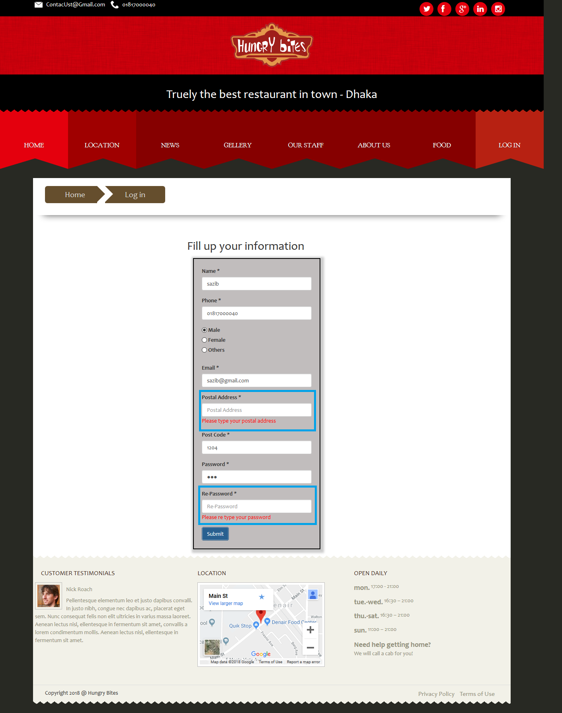

Figure: Error message for input.

|  |  |  |  |  |
| --- | --- | --- | --- | --- |
| Unit Test 2 | | Tests Class: Signup | Designed by : Sazib Hossain | |
| Data source: User Entry | | Objective: test basic functionality | Tested by : Sazib hossain | |
| Test Case | Description | Tasks | Expected Result | Actual Result |
| 1.2 | Test for validation if email is already exist. | Username: sazib  Postal Address: dhanmondi  Email : sazib@gmail.com  Password : 123  Gender : Male  Postcode : 1204 | A message will be shown because the email is used to identify the user uniquely. | The system shows message “ Email already exist”. |

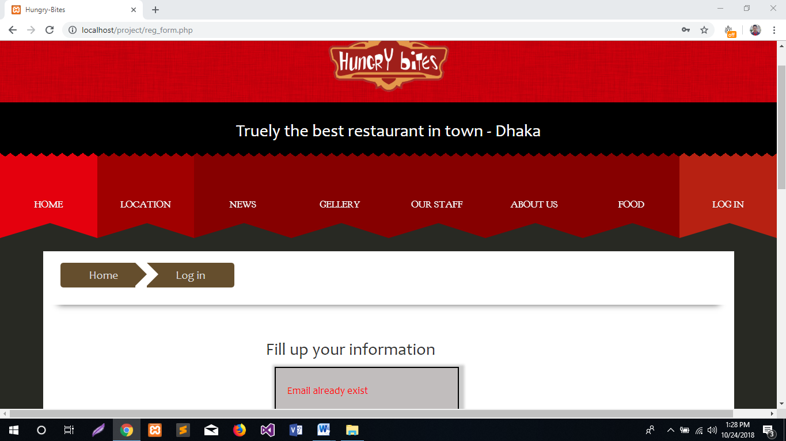

Figure: Error message if email wants to duplicate.

## Integration testing

|  |  |  |  |  |
| --- | --- | --- | --- | --- |
| Integration Testing 1 | | Test Feature: change the user information | Designed by: Sazib hossain | |
| Test case | Description | Tasks | Expected result | Actual result |
| 1.1 | The user will be able to edit or update their information. | The user will change their name. | By clicking submit option the user will change his name. | After clicking submit button the username turned sazib into sazib hossain |

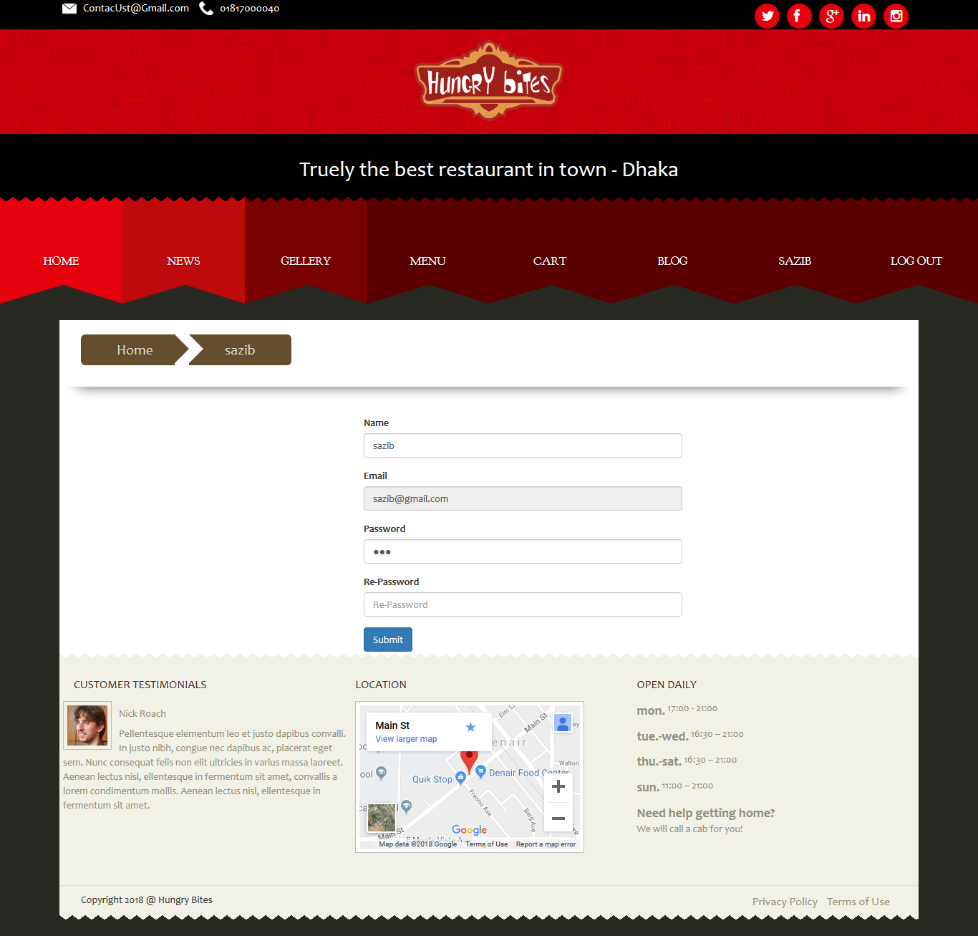

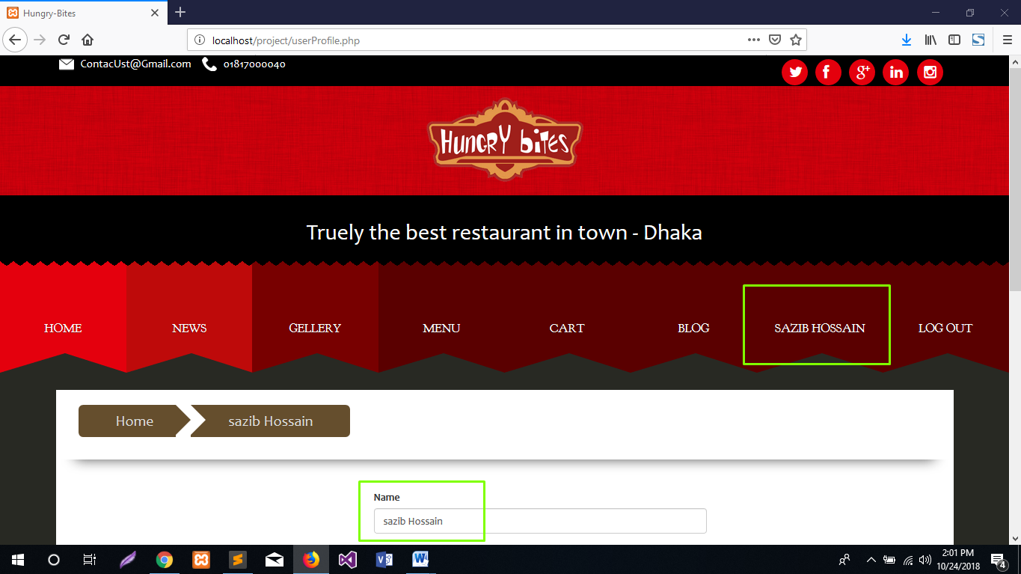

Figure: User updates their name.

|  |  |  |  |  |
| --- | --- | --- | --- | --- |
| Integration Testing 2 | | Test feature- Forum | Designed by: Sazib Hossain | |
| Test case | Description | Tasks | Expected result | Actual result |
| 1.2 | Check the user can make a comment or not. | The user needs to click comment button after typing comment on comment box. | The comment should be displayed. | The comment option is working. |

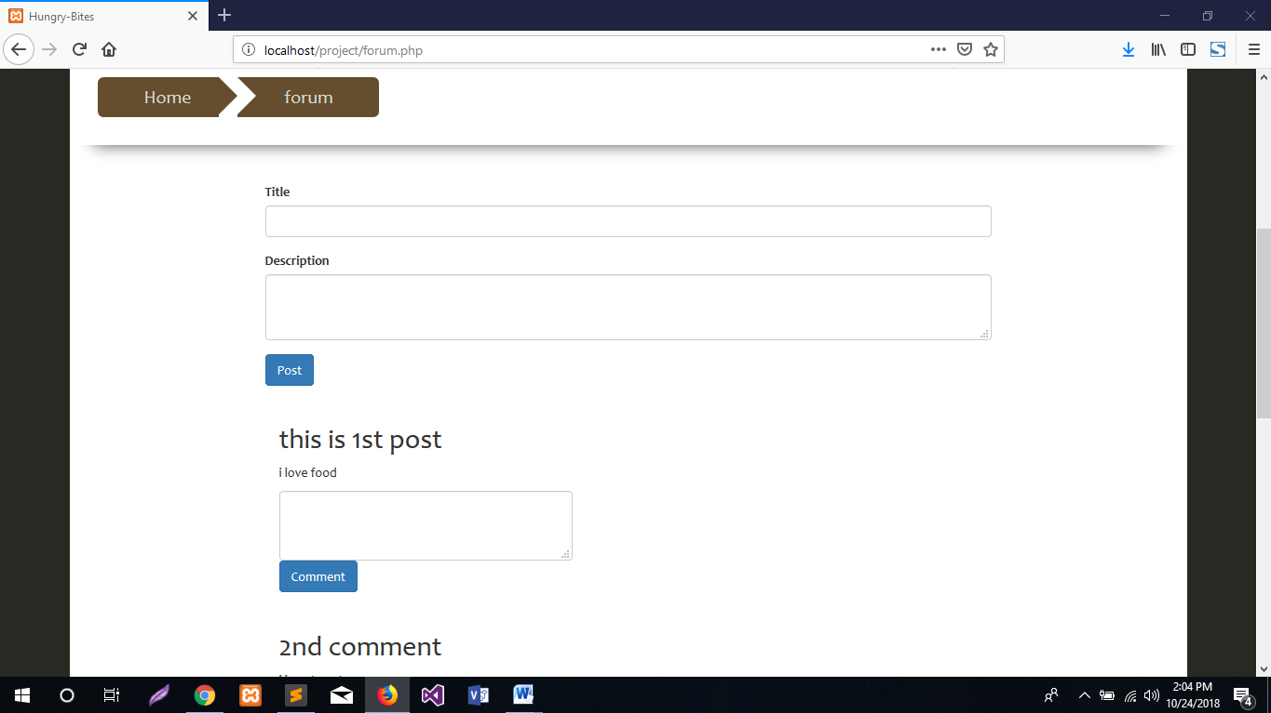

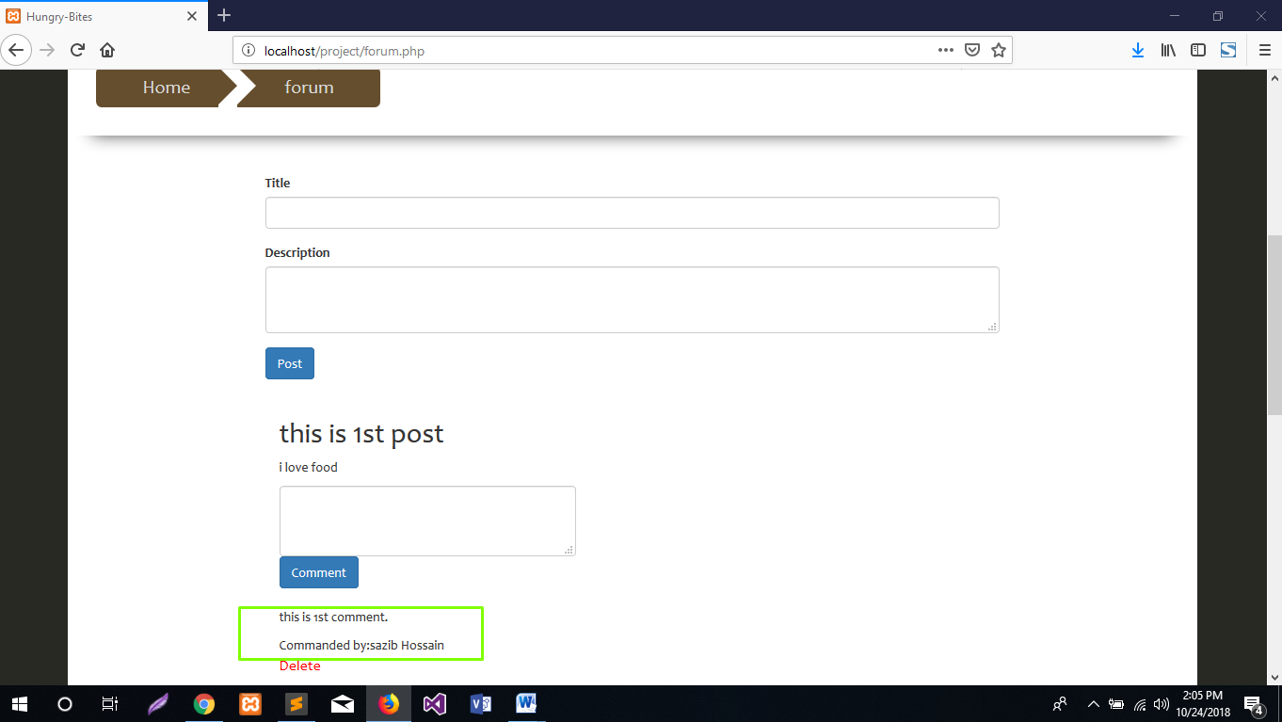

Figure: User creates comments on a post.

Summary: the section is covered with the management of the project, what are the risk factors of this project. Beside this testing section is also covered in this section specially unit testing and integration testing.

Conclusion: Ultimately Hungry Bites Management System is complete. This is the first time I made a project that was not the only supervisor. I do not know what mistakes I have made. But the best thing that happened at this time was that I had the opportunity to learn a lot about my mistakes and I managed to correct these errors and learn more. I've learned many new things to do a thorough analysis of the interface and the perfect system. I have collected a lot of knowledge about PHP working on this project. My mental powers of my mind have grown a lot and now I have become more confident. We also received enough knowledge from the university to approve various stakeholders. Control errors are one of the most challenging challenges I have ever encountered. I learned from the end. I have managed to implement our system management through effective error management.

## Evaluation of work

This section is basically o judge my project by myself. It helps to grow confidence about own work and help find out the fault. Beside this, it also provide better idea to management project in future. The following things should be considered when evaluate the own work.

* Be proud.
* Be honest and critical.
* Continuously strive for growth.
* Track your accomplishments.
* Be professional (Business News Daily, 2018).

|  |  |  |  |  |  |
| --- | --- | --- | --- | --- | --- |
| SL No | Question | Poor | satisfactory | Good | Excellent |
| 1 | How feeling about the project is completed on time? |  |  |  |  |
| 2 | What do you think about the project will meet all the requirements that I have specified in the proposal? |  |  |  |  |
| 3 | How was feeling to do this kind of project? |  |  |  |  |
| 4 | What do you think about your project experience? |  |  |  |  |

## Strength of the system

**User friendly:** the design of the system is very user-friendly. The user will be able to understand and use the system by interacts with the interface. In user interface it is cleared to understand the all basic functions easily.

**Dependent category:** The products are added into the database by controlling category. So that, the user can finds food by selecting category.

**User role control:** the system can control user role. There are two type of user in this system. Different user has access of different function and feature.

**Easy order process:** by using this system the user can easily order the food.

**Platform independent:** as my project was web based. Most of the organization used web based application now a day. So, anyone can access in the system from anywhere through internet.

## Weakness of the project

**Email verification:** The system does not verify the email when the user wants to registration. This is the weakest point in this system.

**Back up Data:** the database does not take automatically data for backup. If any problem occurs such as disaster or server failure, it will be very harmful for the organization.

**Payment method:** the system does not provide any sort of online payment method.

## Further development:

The system need to add some functionality and flexibility to get better performance. The following functionality can be added for the further development:

**Email confirmation:** the system will check that the using email is really belongs to users or not. For this after input the email a confirmation can be sent to the user input email and the user will confirm providing email. This function should take as must have function for further development.

**Adding Account section:** the development system does not include account section of the organization. It should be included in this system rather using another system for the account system.

**Report generating:** In admin panel the system does not generate report such as how product are sold in a days and how many staff are present in a month.

**Payment System:** The current system does not provide any online method. It follows hand to cash delivery. But in order to be a full online system it is necessary to add payment method gateway for transaction.

# Bibliography

Agilebusiness (2018) *https://www.agilebusiness.org*, [Online], Available: <https://www.agilebusiness.org/what-is-dsdm> [10 21 2018].

BD Stall (2018) *http://www.bdstall.com*, [Online], Available: <http://www.bdstall.com/details/cisco-rv110w-300mbps-4-port-wireless-n-vpn-firewall-router-26623/> [22 Oct 2018].

Bisk Education (2018) *https://www.villanovau.com*, [Online], Available: <https://www.villanovau.com/resources/project-management/5-phases-project-management-lifecycle/#.W89IrEszbIU> [23 Oct 2018].

Business News Daily (2018) *Business News Daily*, [Online], Available: <https://www.businessnewsdaily.com/5379-writing-self-assessment.html> [2018].

Digital Ocean (2018) *Digital Ocean*, [Online], Available: <https://www.digitalocean.com/community/tutorials/an-introduction-to-configuration-management> [25 Oct 2018].

Food Panda (2018), [Online], Available: <https://www.foodpanda.com.bd/> [2018].

Hungry Naki (2018), [Online], Available: <https://www.hungrynaki.com/> [2018].

Investopedia (2018) *https://www.investopedia.com*, [Online], Available: <https://www.investopedia.com/terms/f/feasibility-study.asp> [24 Oct 2018].

Mukund (2018) *https://www.simplilearn.com*, [Online], Available: <https://www.simplilearn.com/feasibility-study-article> [22 Oct 2018].

Pathao (2018), [Online], Available: <https://pathao.com/food> [2018].

Project Smart (2018) *projectsmart*, [Online], Available: <https://www.projectsmart.co.uk/moscow-method.php> [24 Oct 2018].

Sauter, V.L. (2018) *http://www.umsl.edu*, [Online], Available: <http://www.umsl.edu/~sauterv/analysis/prototyping/proto.html> [21 Oct 2018].

Shetty, D. (2018) *Business Performance Pty Ltd*, [Online], Available: <http://www.businessperform.com/articles/training-practice/planning-training-projects.html> [24 Oct 2018].

Star Teach (2018) *https://www.startech.com.bd*, [Online], Available: <https://www.startech.com.bd/index.php?route=product/search&search=pc&category_id=0> [22 Oct 2018].

Techopedia (2018) *https://www.techopedia.com*, [Online], Available: <https://www.techopedia.com/definition/3983/structured-systems-analysis-and-design-method-ssadm> [21 Oct 2018].

UMSL (2018) *http://www.umsl.edu*, [Online], Available: <http://www.umsl.edu/~sauterv/analysis/F08papers/Katimuneetorn_Feasibility_Study.html> [2018].

# Appendix:

## Requirements specification:

|  |  |  |  |
| --- | --- | --- | --- |
| **No** | **Requirements Name** | **Priority** | **Requirement type** |
| 1 | Showing Food item | High | Functional |
| 2 | Add to cart | High | Functional |
| 3 | Post on the Forum | High | Functional |
| 4 | Comment on the forum | High | Functional |
| 5 | Delete comment | Medium | Functional |
| 6 | Remove food item from cart | Medium | Functional |
| 7 | Take attendance | High | Functional |
| 8 | Add new staff | Medium | Functional |
| 9 | Add food item | High | Functional |
| 10 | Notify user | High | Functional |

## Use case Description:

|  |  |
| --- | --- |
| **UCD-1** | **Registration and Log in** |
| **Use Case Description** | The users will provide their information for registration and provide registered email and password for log in. |
| **Primary Actor** | User |
| **Secondary Actor** | Admin |
| **Basic flow of event** | * Insert information into database. * Match email with registered email * Logged into the system |

|  |  |
| --- | --- |
| **UCD-2** | **Forum post and comment** |
| **Use Case Description** | Both the user and admin will be able to post on the forum as well as comments against post. |
| **Primary Actor** | User |
| **Secondary Actor** | Admin |
| **Basic flow of event** | * User and Admin can post on the forum. * User and Admin can comments against the post. |

|  |  |
| --- | --- |
| **UCD-3** | **Order food** |
| **Use Case Description** | The user will be order food by selecting category. |
| **Primary Actor** | User |
| **Secondary Actor** | None |
| **Basic flow of event** | * Select food by category. * Add to cart food. * order food |

|  |  |
| --- | --- |
| **UCD-4** | **Upload Food item** |
| **Use Case Description** | The admin will be able to add product in the system. |
| **Primary Actor** | User |
| **Secondary Actor** | None |
| **Basic flow of event** | * Fill up all the field of product item form. * By selecting category the product will be uploaded. |

|  |  |
| --- | --- |
| **UCD-5** | **Accept or reject order** |
| **Use Case Description** | The admin can accept or reject the order. |
| **Primary Actor** | Admin |
| **Secondary Actor** | None |
| **Basic flow of event** | * accept or reject order |

|  |  |
| --- | --- |
| **UCD-6** | **Notify User** |
| **Use Case Description** | The admin will be able to notify the entire customer at a time. |
| **Primary Actor** | Admin |
| **Secondary Actor** | None |
| **Basic flow of event** | * an email will be sent to the users |

|  |  |
| --- | --- |
| **UCD-6** | **Take Attendance** |
| **Use Case Description** | The admin will all the staff attendance. |
| **Primary Actor** | Admin |
| **Secondary Actor** | None |
| **Basic flow of event** | * Taking attendance daily basis. * Add new staff. |

## Testing:

|  |  |  |  |  |
| --- | --- | --- | --- | --- |
| Integration Testing -1 | | Test feature- Staff Attendance | Designed by: Sazib Hossain | |
| Test case | Description | Tasks | Expected result | Actual result |
| 1.2 | The admin will be able to take attendance. | The admin will click on the submit button and data will be saved. | The staff attendance will be stored. | The submit button is working. |

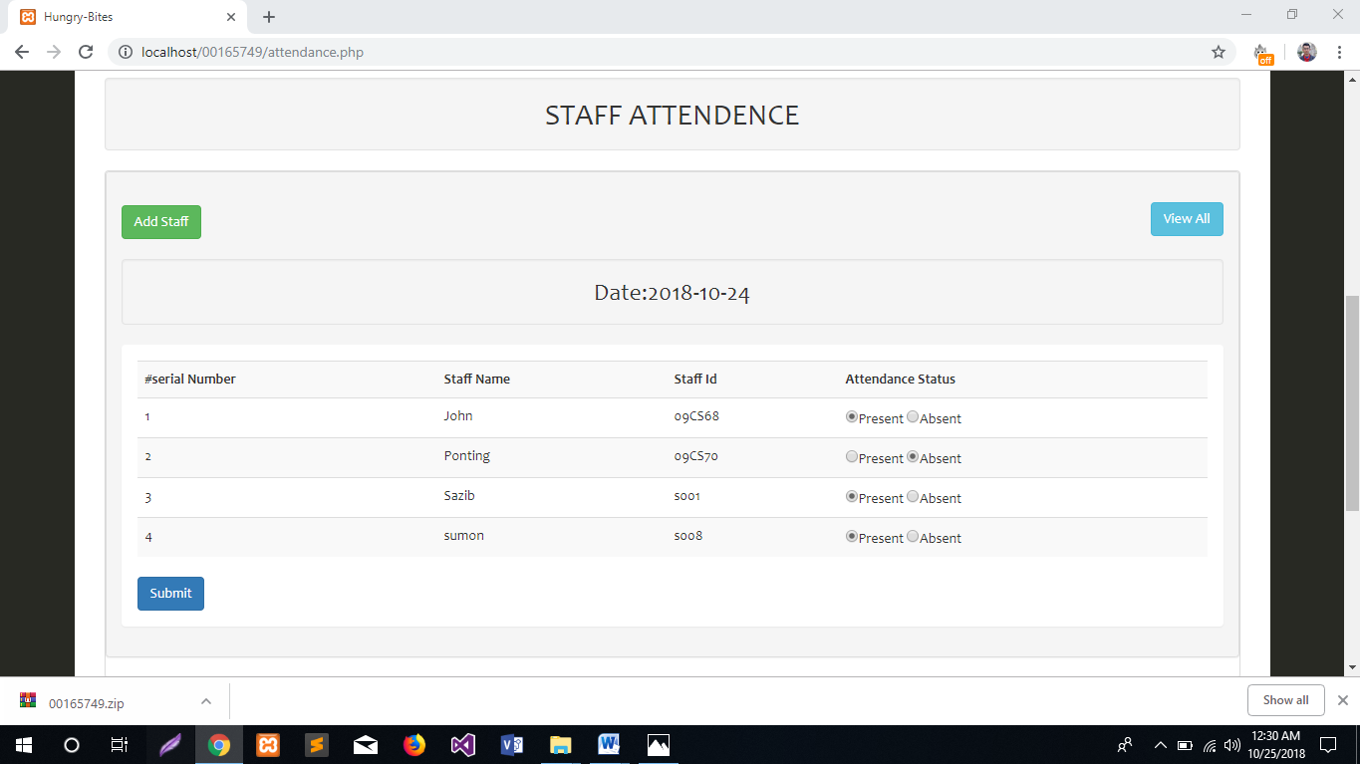

Figure-1: Taking staff attendance.

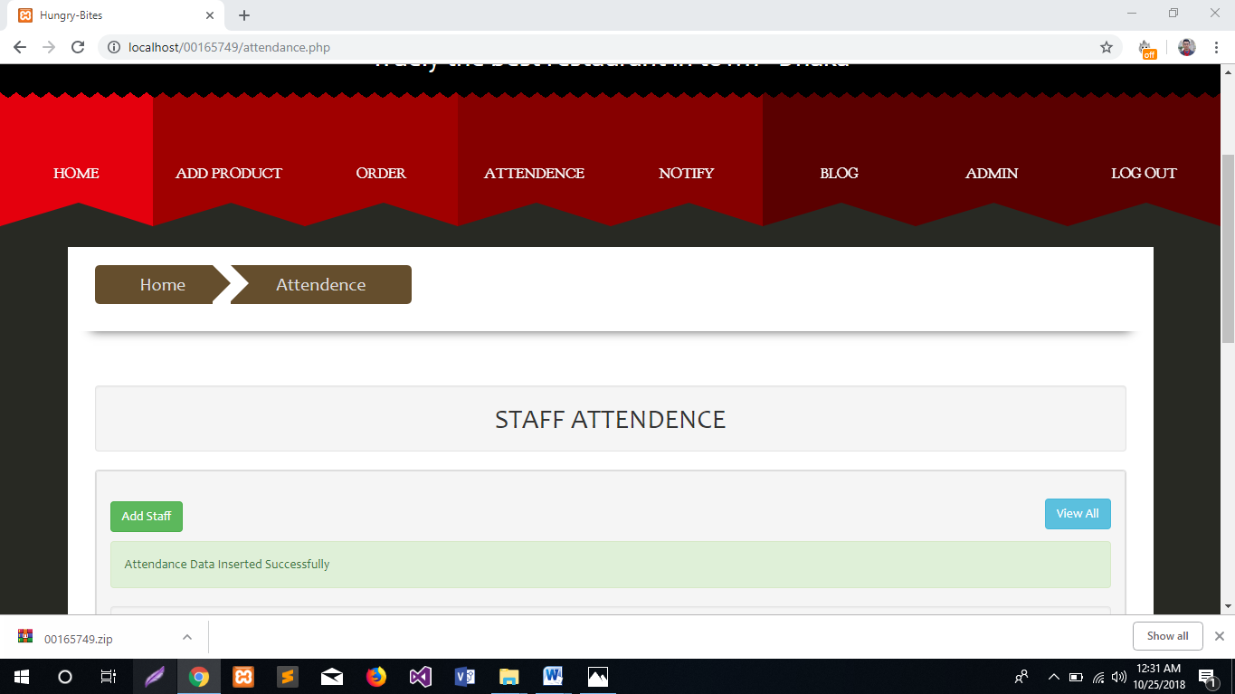

Figure-2: Taking staff attendance.

**Update attendance**

|  |  |  |  |  |
| --- | --- | --- | --- | --- |
| Integration Testing -2 | | Test feature- Update attendance. | Designed by: Sazib Hossain | |
| Test case | Description | Tasks | Expected result | Actual result |
| 1.2 | The admin will be able to update attendance. | The admin will click on the submit button and data will be re saved. | The updated record will be stored. | The submit button is working. Getting expected result. |

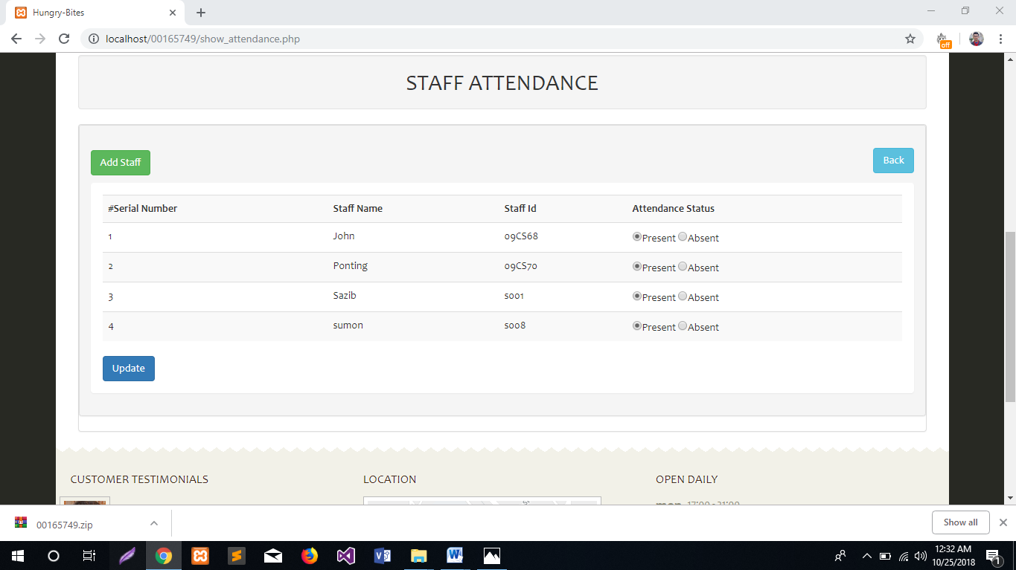

Figure-3: Update staff attendance.

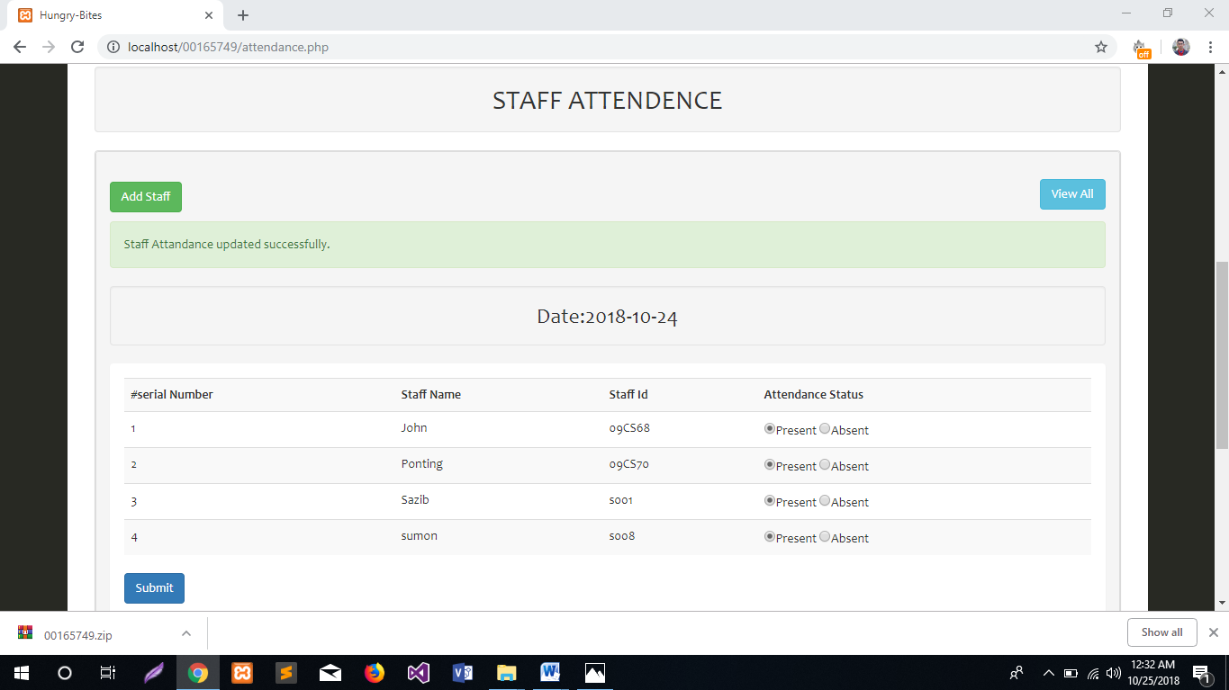

Figure-4: Update staff attendance.

**Add staff**

|  |  |  |  |  |
| --- | --- | --- | --- | --- |
| Integration Testing -3 | | Test feature- Add new staff. | Designed by: Sazib Hossain | |
| Test case | Description | Tasks | Expected result | Actual result |
| 1.2 | The admin will be able to add new staff. | The admin will click on add new staff a form will displayed. | New staff will be added. | After submitting button new staff added. |

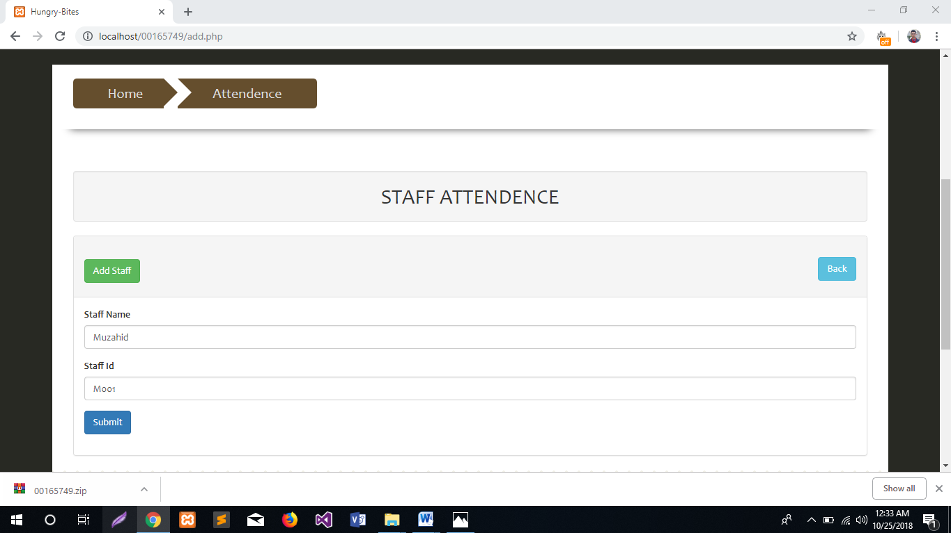

Figure-5: add new staff.

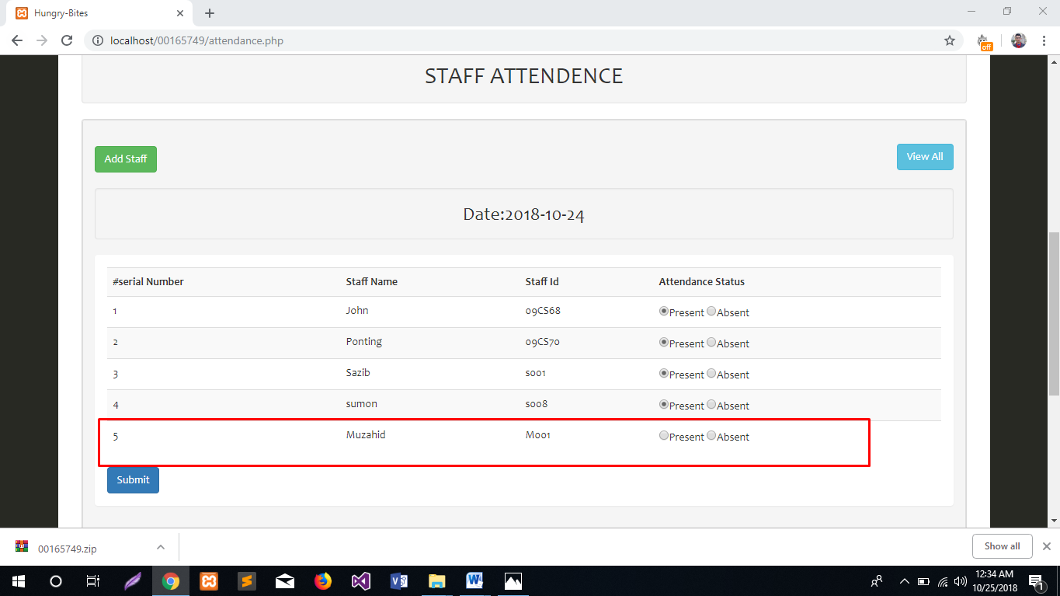

Figure-6: add new staff.

**Add product**

|  |  |  |  |  |
| --- | --- | --- | --- | --- |
| Integration Testing -4 | | Test feature- Add new staff. | Designed by: Sazib Hossain | |
| Test case | Description | Tasks | Expected result | Actual result |
| 1.2 | The admin will be able to add new product. | The admin will click on add product form a form will displayed. After fill up the entire field submit button will click. | New food item will be added. | After clicking submitting button new food item added. getting expected result. |

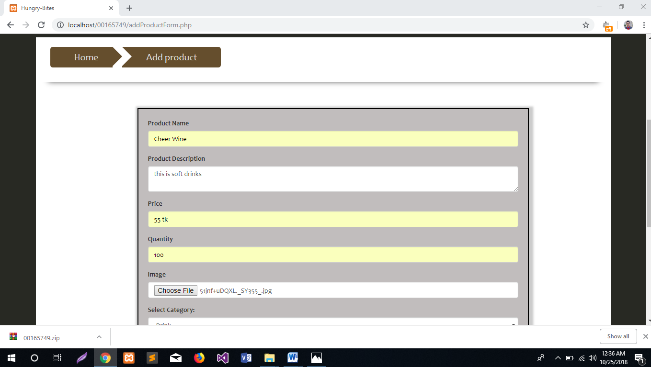

Figure-7: add new food item.

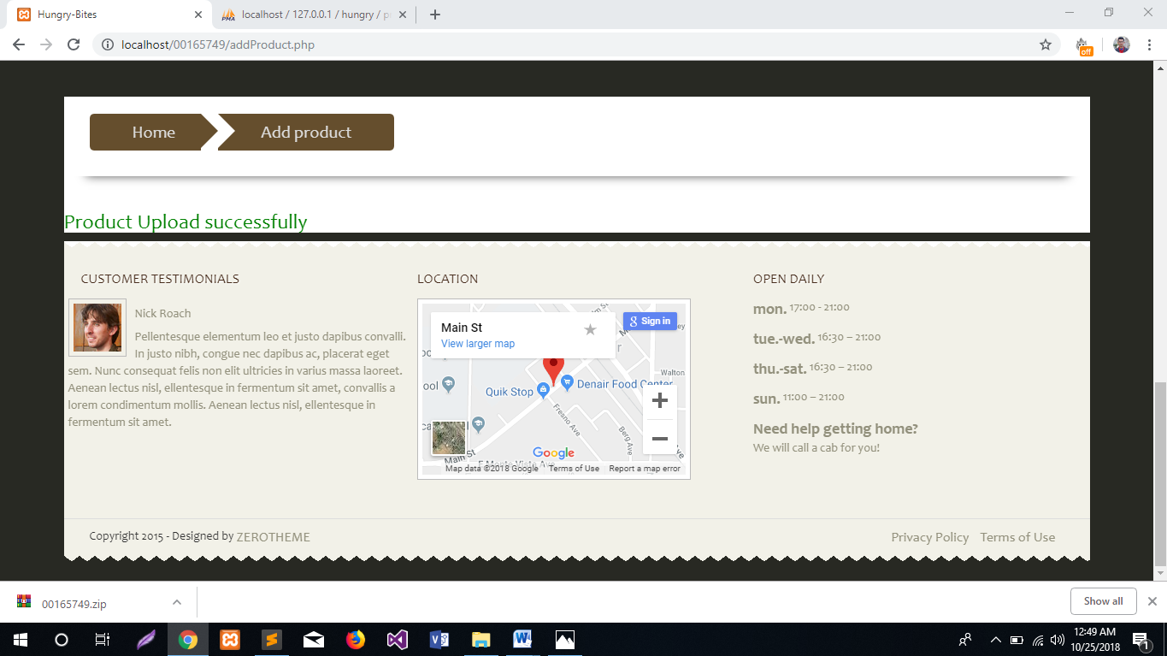

Figure-8: add new food item.

**Select food by category**

|  |  |  |  |  |
| --- | --- | --- | --- | --- |
| Integration Testing -5 | | Test feature- select food by category. | Designed by: Sazib Hossain | |
| Test case | Description | Tasks | Expected result | Actual result |
| 1.1 | The user will be able to see the all product as well as search by through category. | The user will click on the menu and the menu page will be displayed. After fill up the entire field submit button will click. | The user will be able to choice food through category. | The user can chose food through category. The system provide expected result. |

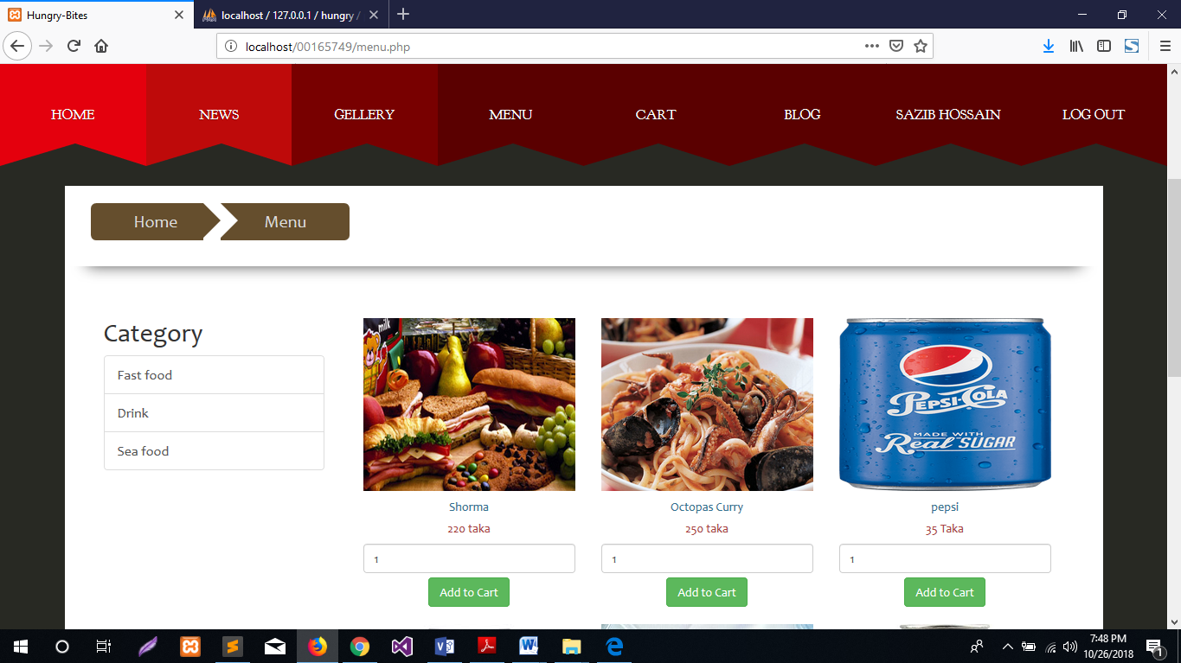

Figure: menu page.

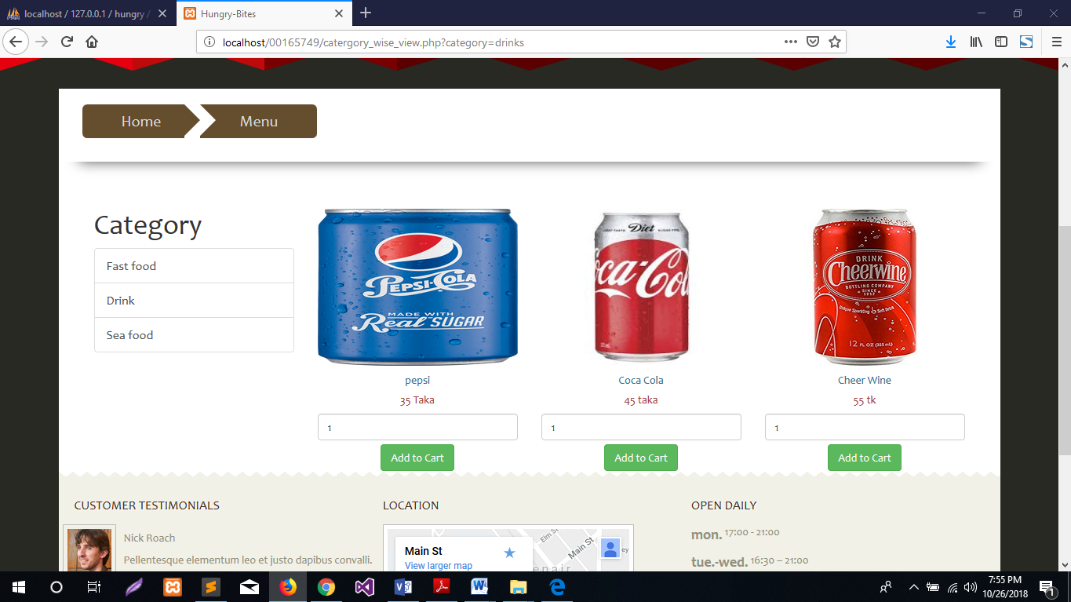

Figure: Only drink category displayed.

**Foods add to cart:**

|  |  |  |  |  |
| --- | --- | --- | --- | --- |
| Integration Testing -6 | | Test feature- select food by category. | Designed by: Sazib Hossain | |
| Test case | Description | Tasks | Expected result | Actual result |
| 1.1 | The user will be able to add food in cart page category. | The user will click on the add button and the foods will be insert into the cart table. | Food will be added cart page. | The system provides expected results. |

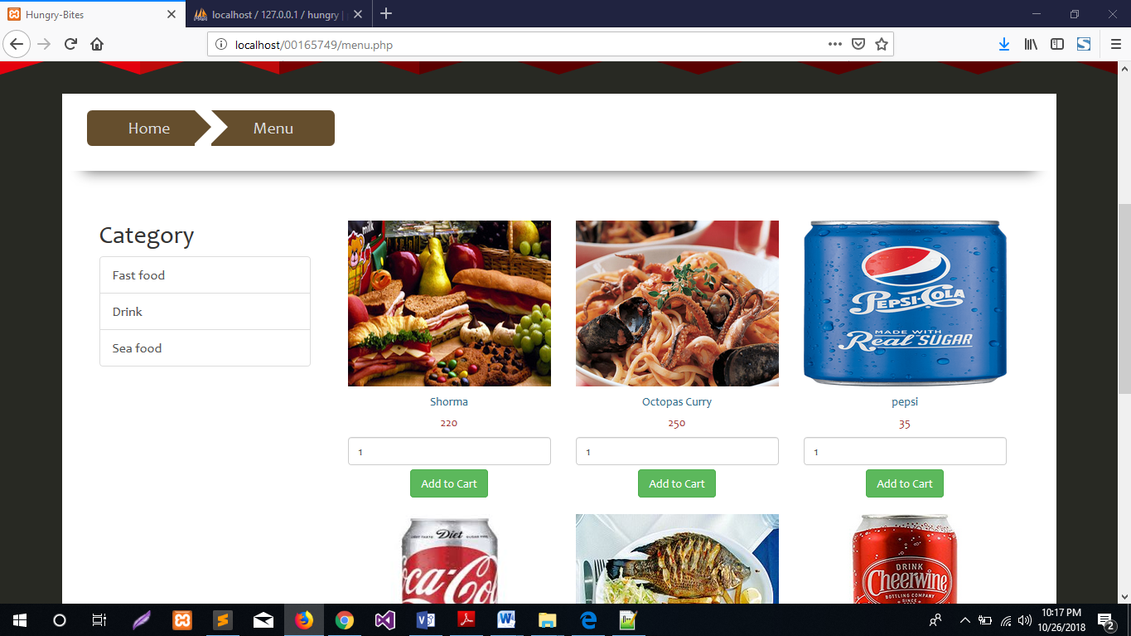

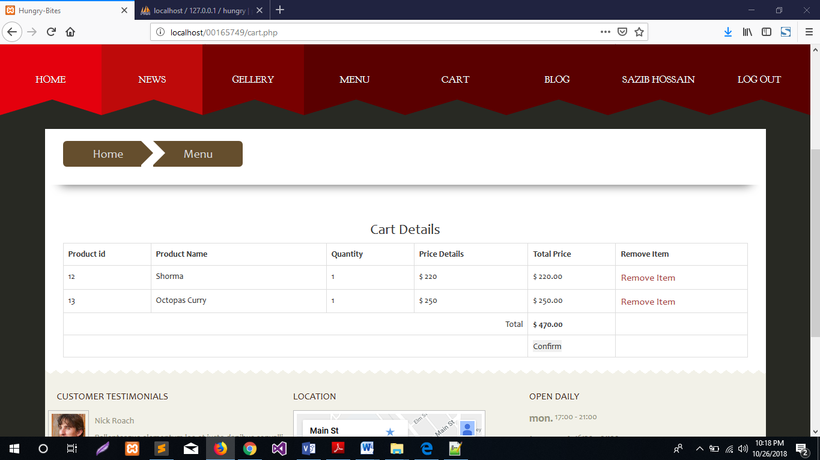

Figure: foods insert into cart table.

## User Guide

User guide is mainly for suggest how the user will be able to use the system. I am going to describe the user guide with screenshots.

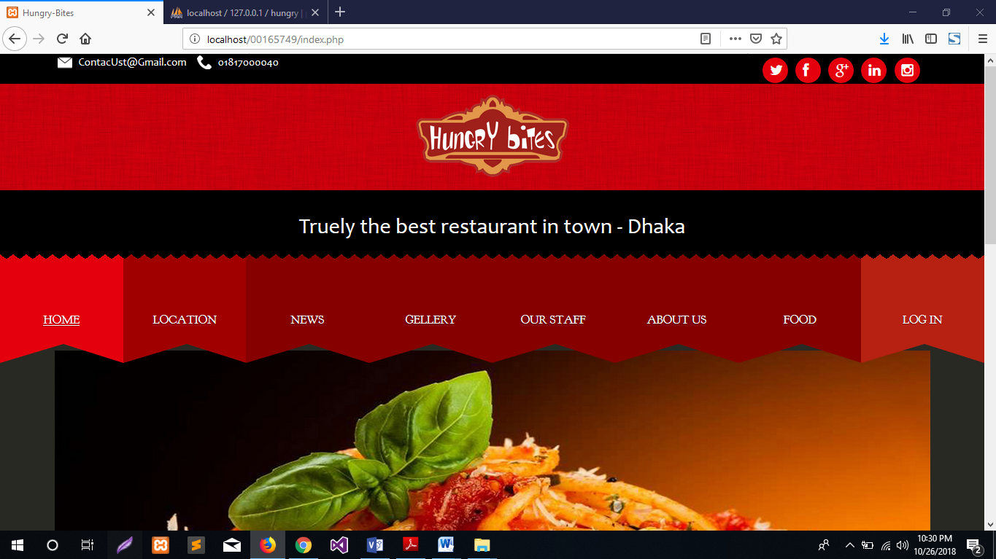

Figure: first page of the system

After that the user will click log on log in and click as new member then a form will be displayed. There the user will provide their information and will be registered.

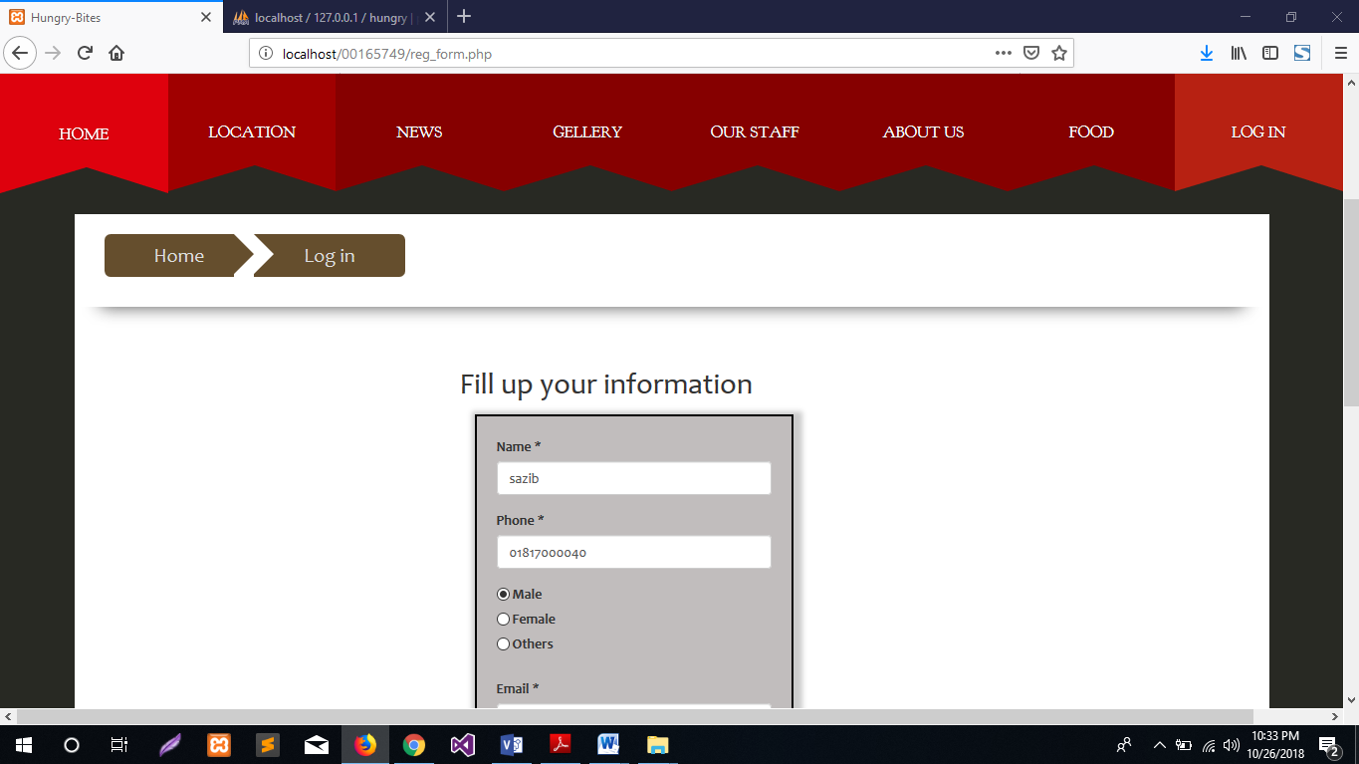

Figure: registration page.

After completing the user will be ready for to use the system effectively. Then the user will logged in with the registered email and password.

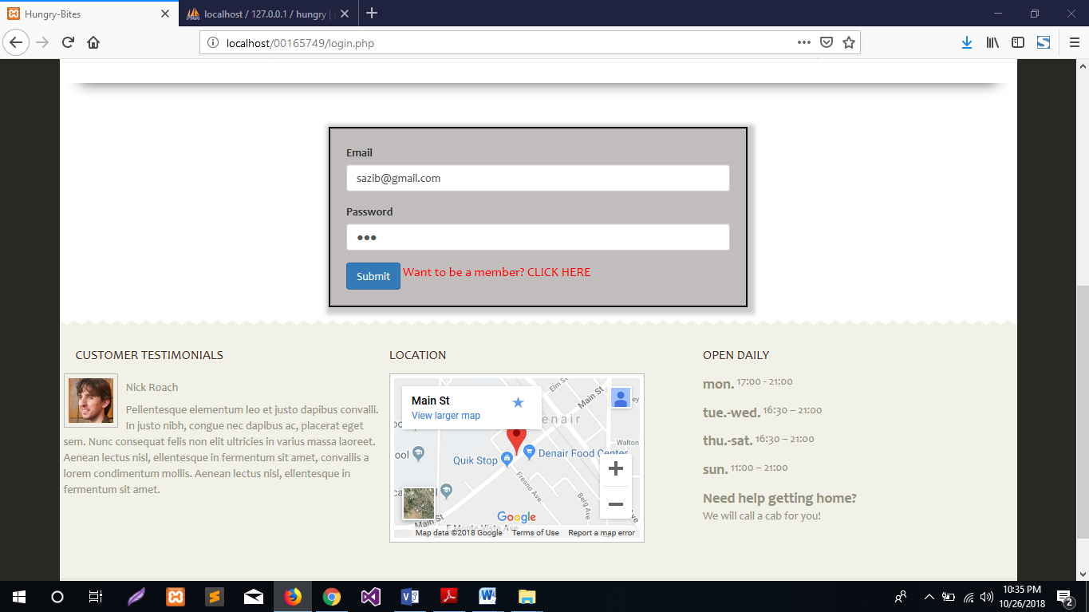

Figure: Log in page

After logged in the user will be able to see the menu page and blog page. then the user can select food.

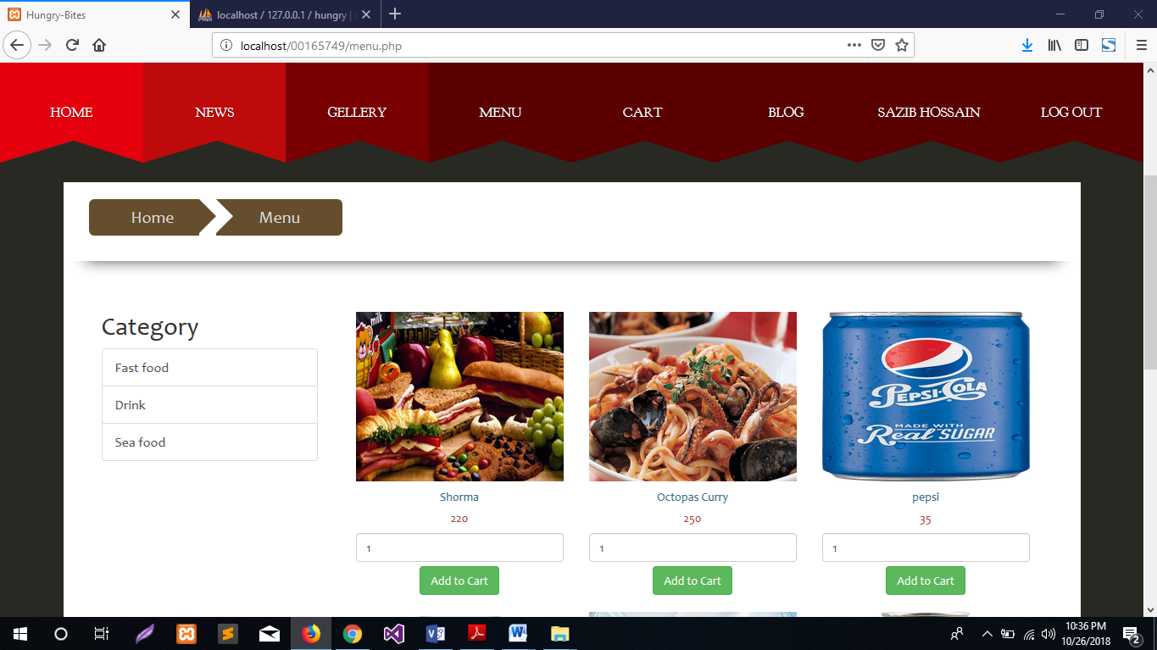

Figure: menu page

Then the user can select food and get into cart page. in cart page the user also can remove item.

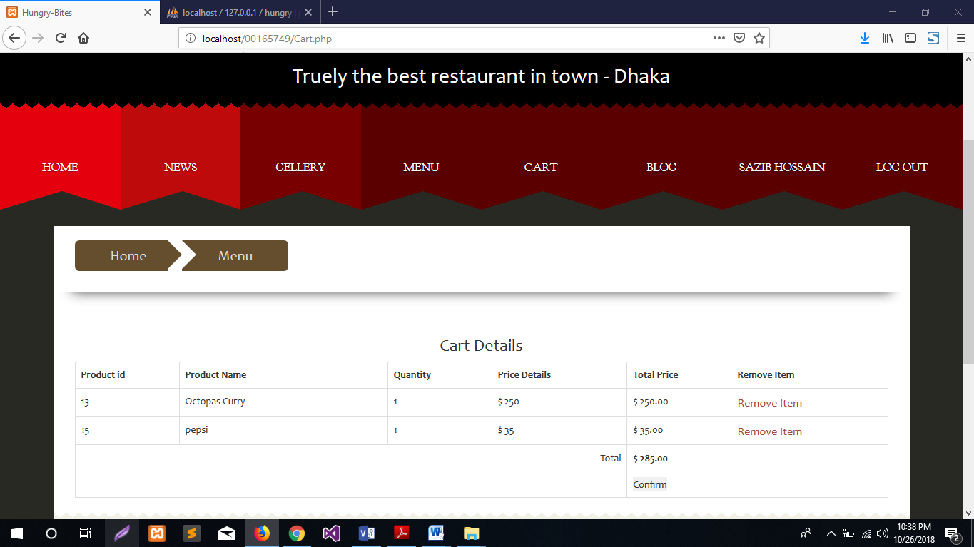

Figure: cart page.

The user also can post and comment on blog page.

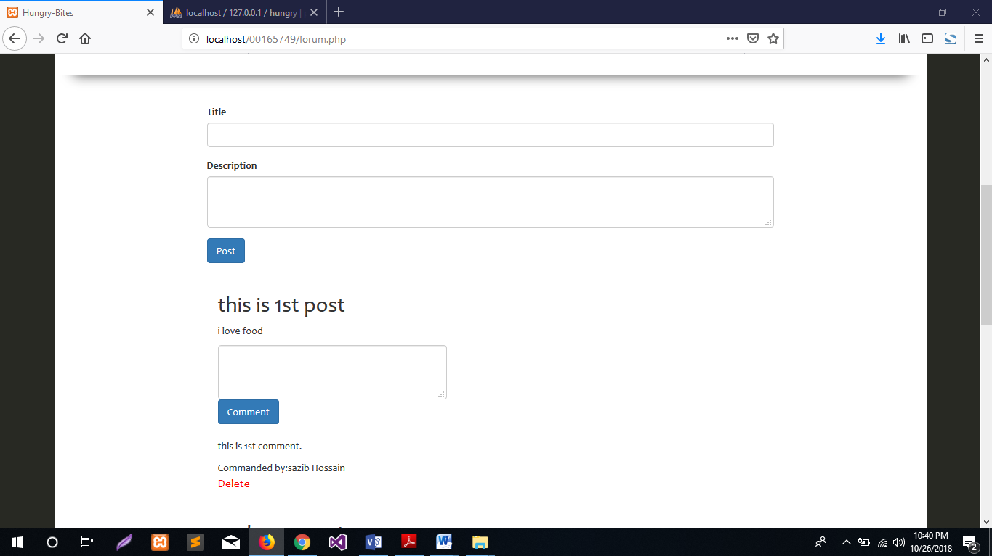

Figure: Blog page.

## System code:

**Profile information update:**

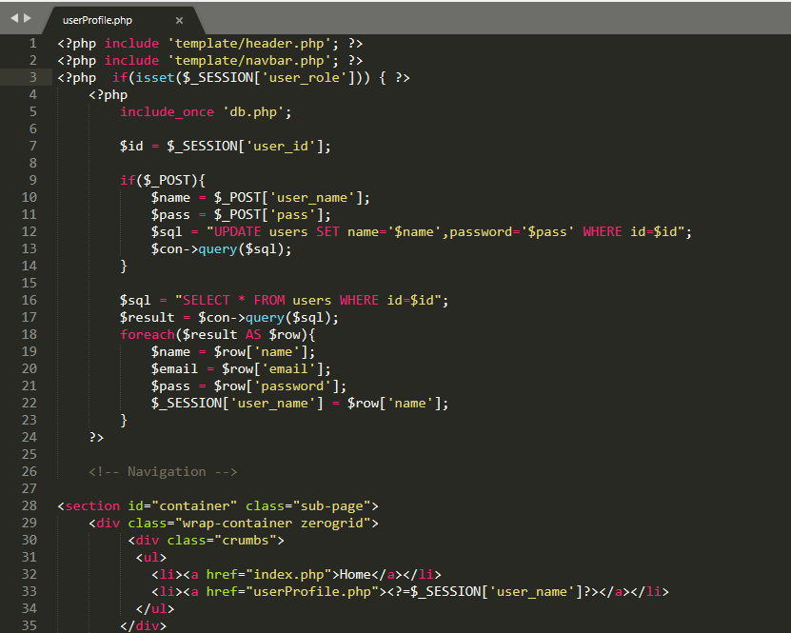

Figure: Update user information code

**Registration validation:**

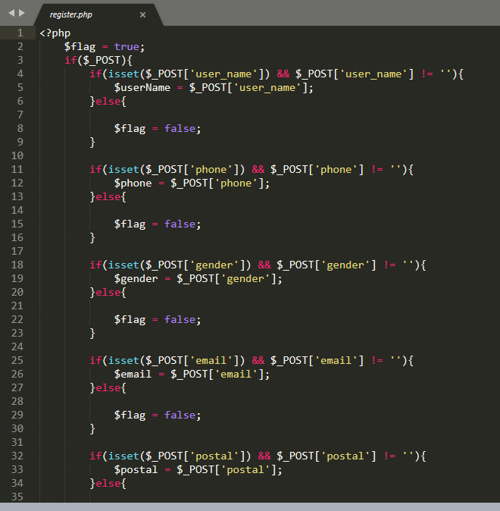

Figure: User registration form field validation.